**DAILY ONLINE ACTIVITIES SUMMARY**

|  |  |  |  |  |  |  |
| --- | --- | --- | --- | --- | --- | --- |
| **Date:** | | **08 July 2020** | **Name:** | | **KHATHEEJA SAFREENA.** | |
| **Sem & Sec** | | **4th sem, 2nd year** | **USN:** | | **4al18cs037** | |
| **Online Test Summary** | | | | | | |
| **Subject** | **-----** | | | | | |
| **Max. Marks** | **----** | | | **Score** | **---** | |
| **Certification Course Summary** | | | | | | |
| **Course** | | **GOOGLE DIGITAL MARKETING.** | | | | |
| **Certificate Provider** | | **Google digital garage.** | | **Duration** | | **40 hours** |
| **Coding Challenges** | | | | | | |
| **Problem Statement:1 program** | | | | | | |
| **Status: Executed** | | | | | | |
| **Uploaded the report in Github** | | | | **Yes** | | |
| **If yes Repository name** | | | | [http://shafreenasharief / lockdown-coding](http://shafreenasharief / lockdown-coding" \o "http://shafreenasharief / lockdown-coding) | | |
| **Uploaded the report in slack** | | | | **Yes** | | |

Certification Course Details: (Attach the snapshot and briefly write the report for the same)

Coding Challenges Details: (Attach the snapshot and briefly write the report for the same)

#### ONLINE TEST:

#### Today we attended DAA first IA test.

**CERTIFICATION COURSE SUMMARY:**

Today I started new course **FUNDAMENTALS DIGITAL MARKETING** through **GOOGLE DIGITAL GARAGE** the course is secluded for 6hrs. After the completion of course, certificate will be provided. I completed all the module .I attempted quiz ,which gave me a clear veiw about the topics that were thought and discussed.It consists of 40 modules which also include assessments.

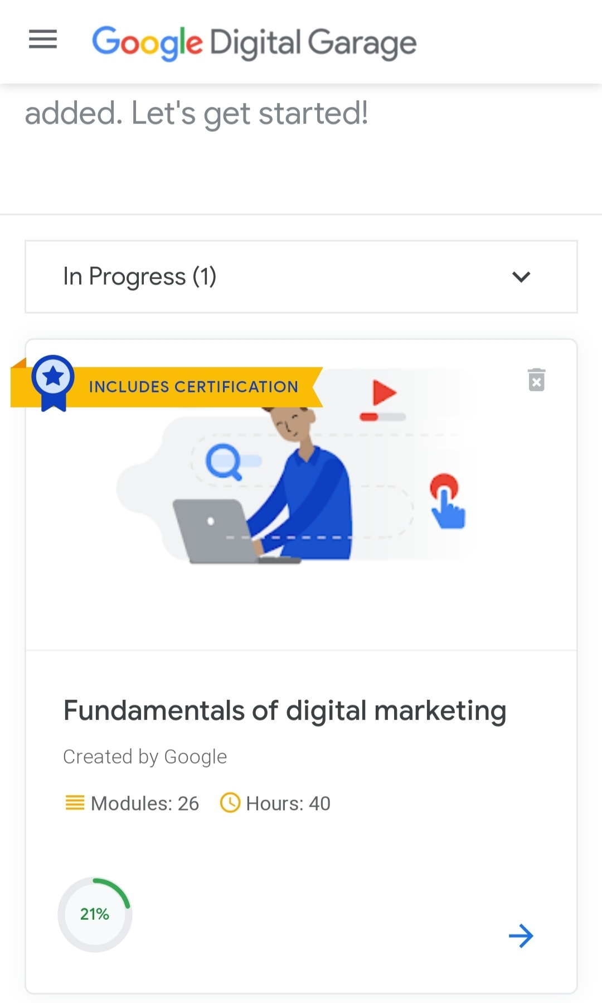

**ONLINE CODING:**

**Given two strings a and b consisting of lowercase characters. The task is to check whether two given strings are anagram of each other or not. An anagram of a string is another string that contains same characters, only the order of characters can be different. For example, “act” and “tac” are anagram of each other.**

**Example:**

**Input:**

alvasinsitute aalvsiittnsue

allergy allergic

**Output:**

YES

NO

**Explanation:**

Testcase 1: Both the string have same characters with same frequency. So, both are anagrams.

Testcase 2: Characters in both the strings are not same, so they are not anagrams.

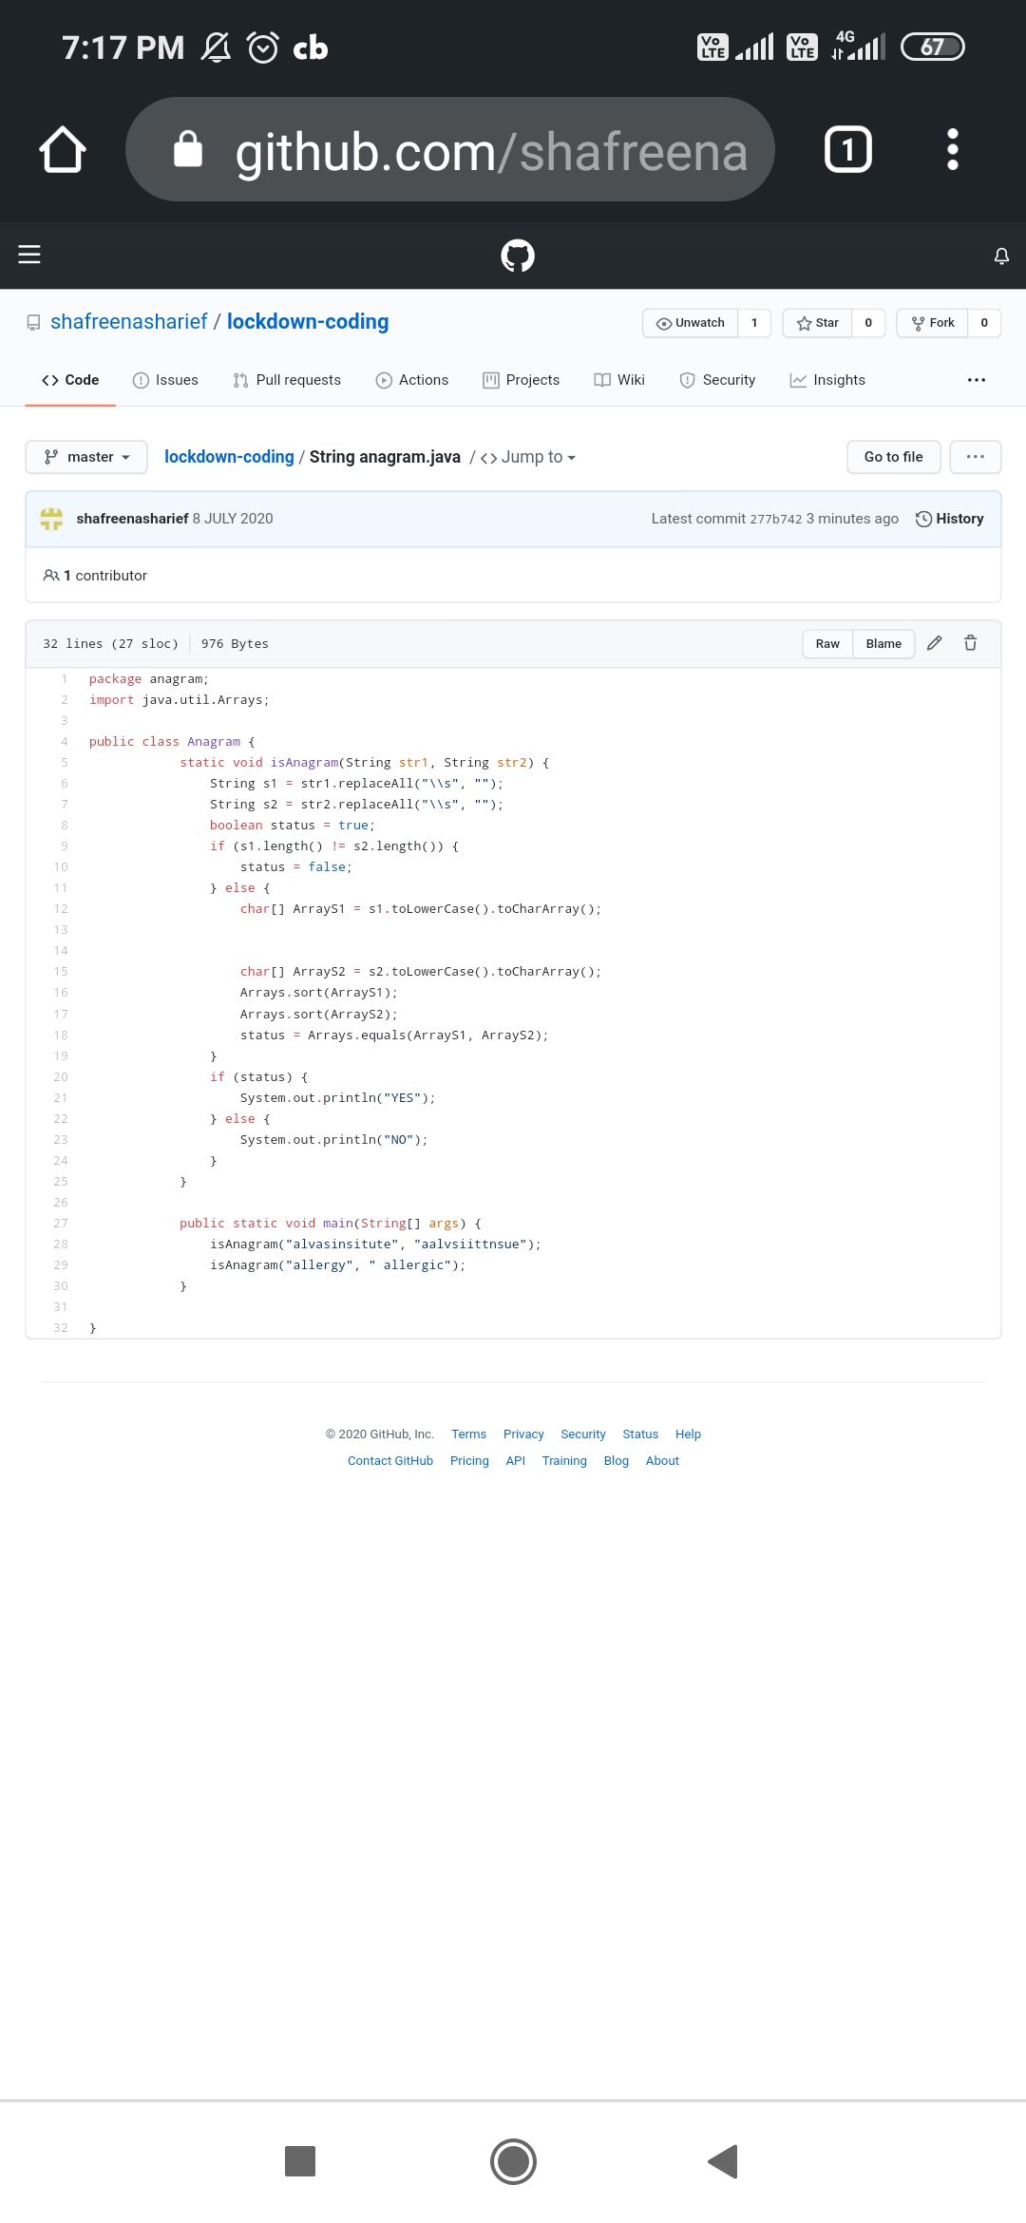

**SOLUTION** : I have uploaded the solution of the above 1 coding problems in my GitHub repository.

[http://shafreenasharief / lockdown-coding](http://shafreenasharief / lockdown-coding" \o "http://shafreenasharief / lockdown-coding)

[http://shafreenasharief / locked-down--certification-course](http://shafreenasharief / locked-down--certification-course" \o "http://shafreenasharief / locked-down--certification-course)

[http://shafreenasharief / Daily\_Report](http://shafreenasharief / Daily_Report" \o "http://shafreenasharief / Daily_Report)